Ouch my Hip!
Many Pilates clients complain of discomfort, pain or clicking over the hip joint area during a Pilates session. We even see clients developing hip pathology although they have been doing Pilates for many years. One of the main aims of the Pilates method is to balance the body. So why is this still happening? The answer is not a simple one but probably related to a number of factors. In order for us to understand what these factors are, we need to have a clear understanding of the anatomy and biomechanics at play at the hip joint, and how this relates to our everyday lives and activities. We also need to remember that balancing the body means a balance between all the lines of the body (anterior, posterior, lateral and medial line).
Anatomy and biomechanics of the hip
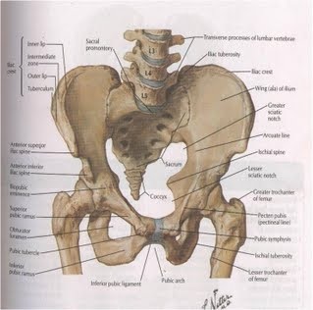

The hip joint is a complex anatomical structure which is composed of osseous, ligamentous and muscular structures responsible for transferring weight of the body from the axial skeleton to the lower limbs. This is achieved while allowing dynamic loading during activities such as gait and balance. The femoroacetabular joint is unique, because this joint is never fully unloaded during daily activities. Even though the time period when maximum load is experienced by the articular surfaces of the hip joint is short, there is a residual compressive force acting across the joint at all times. This force averages the magnitude of approximately the body weight of the person. F.Pauwels (1976) Defined the forces acting around the hip and the moments required to balance the pelvis. The joint’s reactive force is the compressive force experienced at the femoroacetabular joint. This is a result of the need to balance the moment arms of the body weight with the pull of the hip abductors at the great trochanter to maintain a level pelvis. The magnitude of this force will change according to the challenge of activities such as walking up stairs, climbing down a mountain etc. This can be found to be as much as 2 to 4 times the body weight. Sporting activities greatly increase these forces and place their orientation (position) under great strain, requiring the muscular, ligamentous and cartilaginous structures to assist with load transfer. All the different muscles around the lumbopelvic-hip area are at play. Twenty two muscles in total.
These biomechanical factors makes it clear that we need to understand that the hip joint cannot move to achieve optimal function in isolation, but is part of the lumbopelvic–hip region. All three of these areas need to move in optimal patterns during all the hip movements (flexion, extension, adduction and abduction and rotations). One of the most common signs of hip dysfunction is the lack of lateral control of the hip and pelvis in single leg stance. The timing and sequencing of the activation of the various hip muscles have been reported by many authors (e.g. Janda1983; Long et al 1993; Sharmann 2002) to vary. This relates to uncontrolled movements that can take place at the lumbopelvic–hip area.
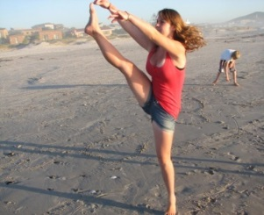
During any hip movement two types of movements take place. 1. Segmental translation movement, which is a small amount of gliding type movement that happens within the joint. 2. Global range movement, which is the movement through its full range. Let’s relate this to the hip flexion movement.

In order to achieve full flexion of the hip joint there needs to be a small amount of gliding movement of the femoral head (segmental) and enough through range movement to achieve full hip flexion. The pattern of movement that is necessary to achieve full hip flexion without any uncontrolled movement, thus depend on enough, but not much or too little gliding movement. This needs to take place within the lumbar spinal joints into flexion. The segmental movement at the SIJ to create posterior pelvic tilt and then the segmental glide in the hip joint itself. This needs to be accompanied by the correct amount of global through range movement at the lumbar spine into flexion, SIJ into nutation to allow adequate posterior tilt at the pelvis and the hip joint into flexion.
Our clients today
When we look at most of our clients daily activities, we will find that 70 % of their working day is taking place in a sitting position. During sitting the hip joint is placed in a position of flexion in the midrange. Therefore it makes sense why so many clients present with weakness in inner and outer range positions of the hip joint. Clients are also gripping and very tight around the anterior line over the hip area, due to this prolonged sitting.
To prepare the joint for exercise it will be most beneficial to relax the tension around the area first by using “switching off” type of excises e.g. like the anatomical hip release .
Anatomical

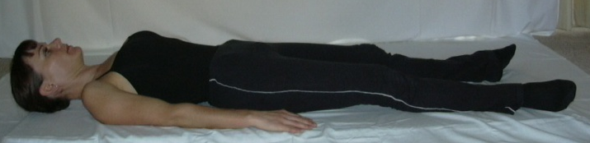
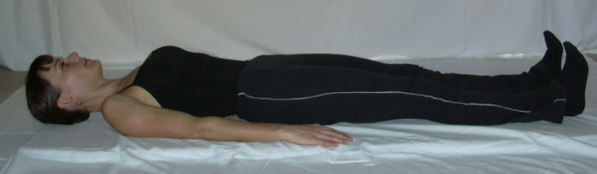

Starting Position | - Supine.
Exercise | - Inhale - prepare.  - Exhale - activate TA and ribs as legs turn to anatomical.  - Inhale - hold.  - Exhale - release legs and pelvis.
Aim | - Maintaining neutral spine with activation of TA, while switching off hip flexors.

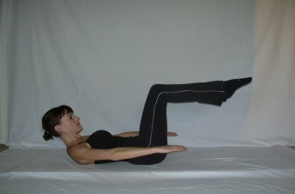
The Pilates trainer needs to be aware of this when planning a Pilates session. The typical Pilates exercises repertoire uses this same mid position of flexion of the hip. The table top position (picture 1) for many of the exercises we use.

Picture 1

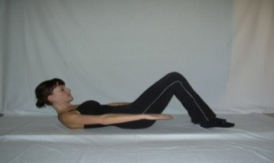
When your client has been in this position most of the day already – is this really the best position to choose? I think not. Modify your starting positions to allow the hip joint to work in inner (shortened position) and outer (lengthened position) range as well. To explain this practically – let’s take a typical Pilates exercises like the AB Prep (Ab-curl). This exercise is usually performed with the legs in crook (picture 2) or double table top position (picture 1).
Picture 2
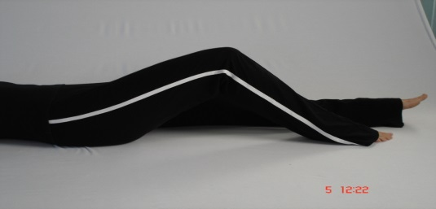
Picture 3

These starting positions can be changed by making some small changes. For example in picture 2, the legs can be moved as far away from the body as the feet can maintain the connection of the triangle under the foot (picture 3). This will just move the hip out of the midrange position to a more outer range position. The double table top can be changed by keeping one leg in double table top and lengthening the other one straight out on the mat. This can then be alternated during the exercise. The upper abdominals are still working effectively and the neutral spine challenged with the hip in outer range position, which will prevent gripping into the hip flexors. This often happens during exercises done in the double table top position, because the client is already fatigued in this position from sitting all day and will move into this compensatory movement pattern immediately.
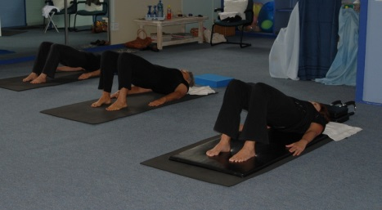
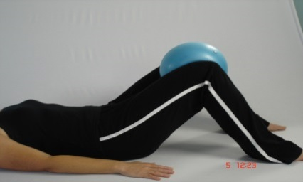
Choose exercises that build all the lines of the body. Most clients (this is a generalisation – as each client should be assessed individually) will present with weakness in their posterior and medial lines due to their modern living. Therefore make sure that you wake up these lines before you start challenging them in your workout.

Picture 4 Picture 5

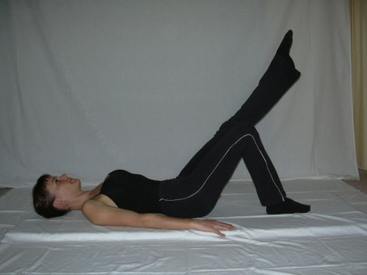
A very effective Pilates exercise to do is the hip roll, holding bridge position at the top with the knees together or holding onto soft ball (picture 5). Then one opens up the tightness of the hip (shortened from prolonged midrange) and strengthens the medial and posterior line.

Picture 6

The hip circles (picture 6) are a very effective Pilates exercise, because it can challenge the hip through range and encourage correct movement patterns. This exercise also encourages control of range of movement, which is so needed in the lumbopelvic-hip area. This is achieved when taught correctly and correct cueing is important. Firing of the pelvic floor muscles and lower abdominals will often relieve clicking and discomfort momentarily during the hip circle exercise, but more importantly what is the natural biomechanics that is taking place when the hip joint moves past inner range to mid and outer range through all positions (flexion, extension, abduction, adduction, medial and lateral rotation). All of these movements take place during the execution of the hip circle. Therefore the most important issue here is that the pelvis and lower back cannot stay static during the movement of the hip into the mid to outer range. There is still stability that is needed in the core to protect the spine and pelvis, but stability and rigidity are often confused here. Our spines are still stable and our cores are still working when our spines move through all its positions. It is because of rigidity in one area of the body that uncontrolled movement starts to happen elsewhere in the body. This could eventually lead to injury and pathology. If we cue the pelvis and lumbar spine to stay neutral and static while the hip is moved into outer range, the body will always choose the path of least resistance to achieve the task at hand (which is move the hip in a full circle). The hip joint will increase the accessory (gliding) movement within the joint. This will put a lot of strain on the joint, the ligaments and soft tissue structures that have to help to absorb this extra force. Let’s consider a soccer player kicking a ball. The player cannot keep his pelvis stable and his back rigid if he really wants to get that ball to travel far. The player has to allow his leg to swing through full hip range, which can only happen if it is accompanied by lumbar flexion and pelvic tilt. This clearly demonstrates that if we want to encourage hip movement, we wouldn’t teach our client to move their hip with a rigid pelvis and spine. If the aim of the exercise is to use the hip movement to encourage stability in the pelvis and lumbar spine in the neutral position, your exercise of choice should be the knee folds where the hip does not move pass 30 degrees.
Conclusion
When planning your workout aim to balance all the lines of the body. Keep your biomechanical and anatomical principles in mind. The Pilates trainer needs to work so much harder in the modern day to strengthen and lengthen the body. Keep on encouraging the clients to move out of their repetitive maladaptive postural and movement patterns. Therefore the days of sticking to set routines and recipes to teach a workout is just not applicable and effective anymore.
Gerda Miller (B.Sc Physiotherapy, US; Stott Pilates Canada)

Bibliography References
Damien P, Byrne*, Kevin J, Mulhall and Joseph F. Baker. – The Open Sports Medical Journal. Anatomy & Biomechanics of the Hip
George, A – Pilates Exercise Focus – How to fix a Snapping Hip. Centreworks ® Blog.
Karl F. Bowman, Jr., M.D., Jeremy Fox, B.A., and Jon K. Sekiya, MD. – A Clinical Relevant Review of the Hip Biomechanics

